**Mac Installation**

1. Download [VirtualBox](https://www.virtualbox.org/wiki/Downloads)
2. VirtualBox 5.0.20 for OS X hosts [amd64](http://download.virtualbox.org/virtualbox/5.0.20/VirtualBox-5.0.20-106931-OSX.dmg)
3. Configure on Mac
4. ~ VBoxManage hostonlyif ipconfig "vboxnet0" --ip 192.168.0.111 --netmask 255.255.255.0
5. VirtualBox > Preferences > Network > Nat Networks

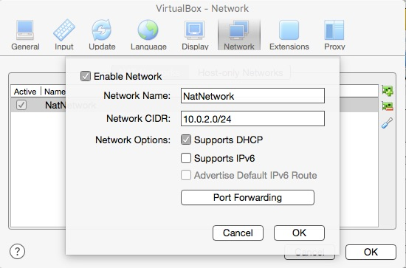

1. VirtualBox > Preferences > Network > Host-only Networks > vboxnet0

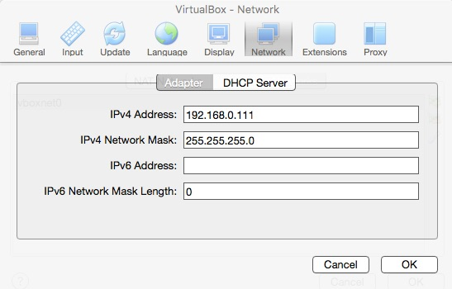

1. Machines > Network > Adapter 1 > Nat >
   1. Adapter Type > Intell PRO/1000 MT Desktop (82540EM)
   2. Cable Connected (checked)
2. Start Windows 8.1 VM
   1. Password: CSNPassword
3. Devices > Insert Guest Additions CD Image (wait 15-30 seconds)
4. Tap to Choose what to do with this disc
   1. Run VBoxWindowsAdditions.exe
5. Restart Windows 8.1 VM